# ***PYTHON IMPORTANT FUNCTION NOTES***

1. Insert function(pos,value)

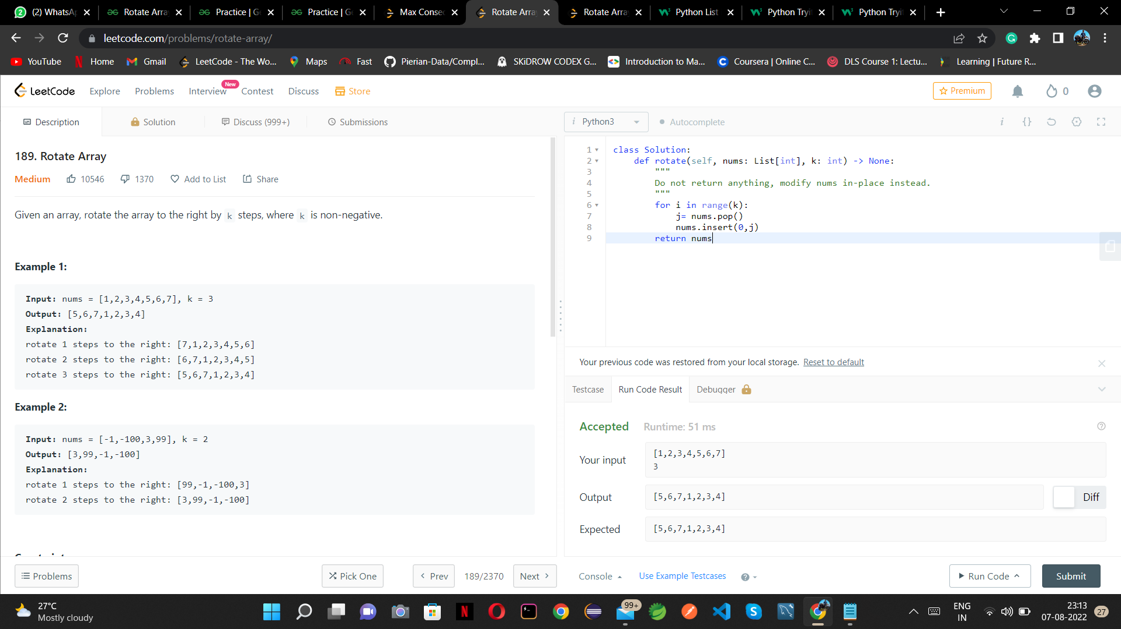

1. Isalnum() 🡪 check whether string is alphanumeric

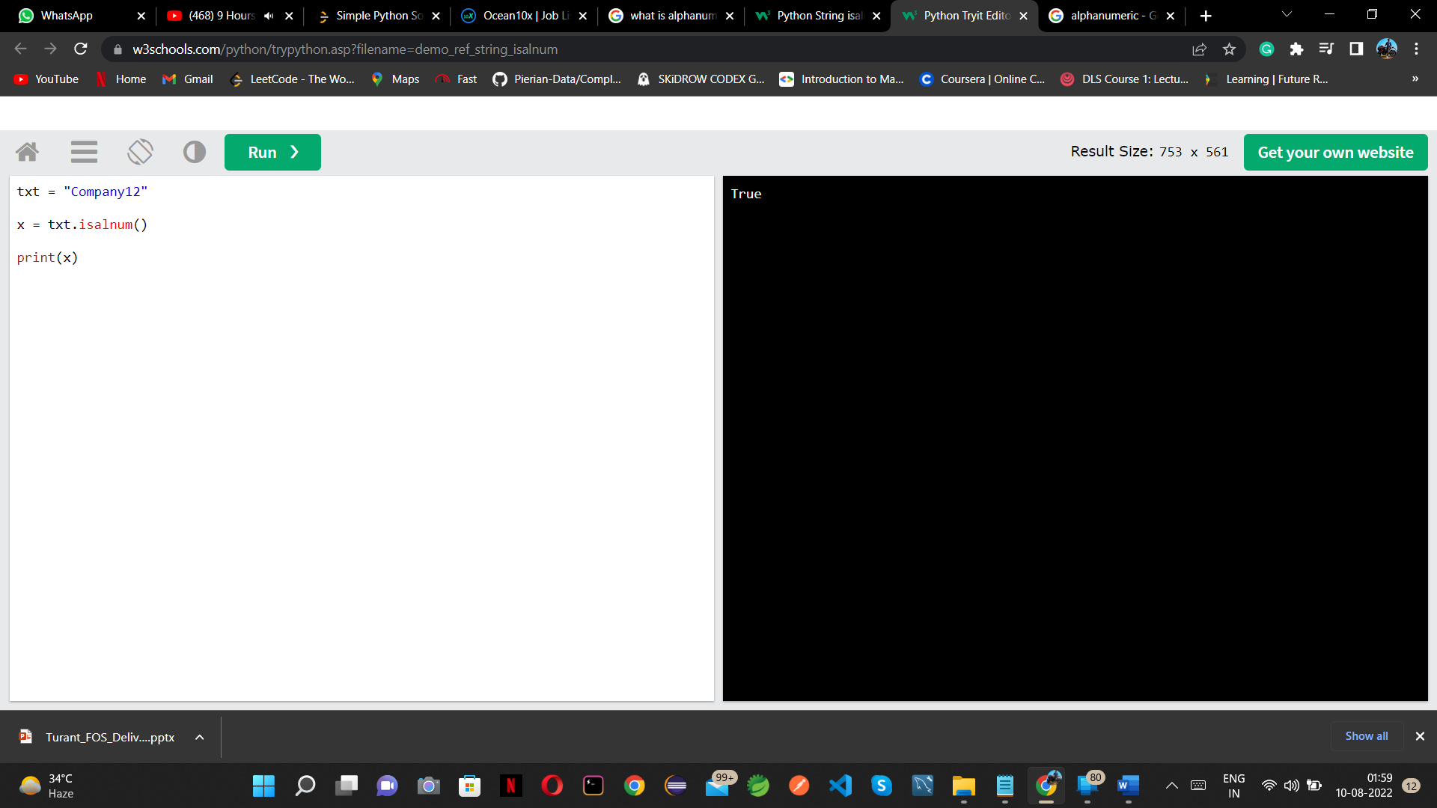

1. Enumerate()

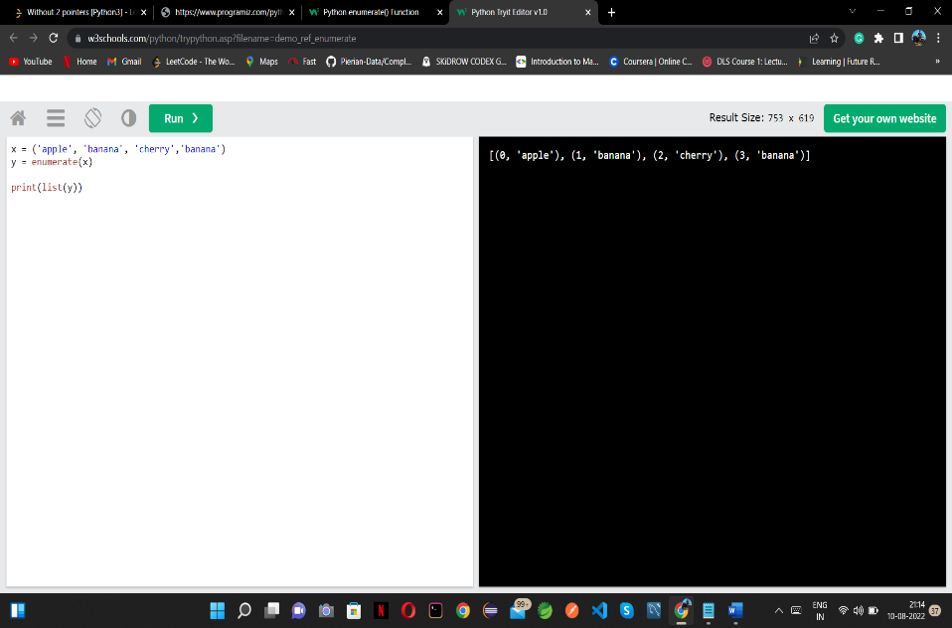

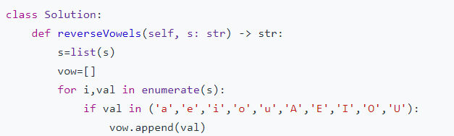

1. Cool property of dictionary must note

How to keep track of character iteration in dictionary

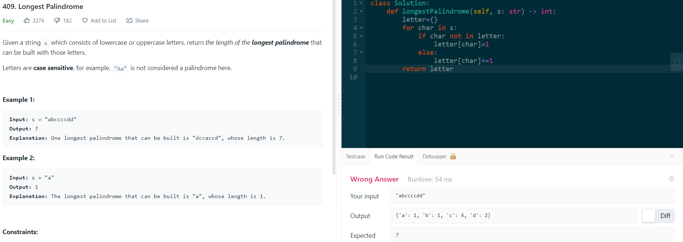

To call the values:

Values()

1. Issubset()🡪The issubset() method returns True if all items in the set exists in the specified set, otherwise it retuns False.

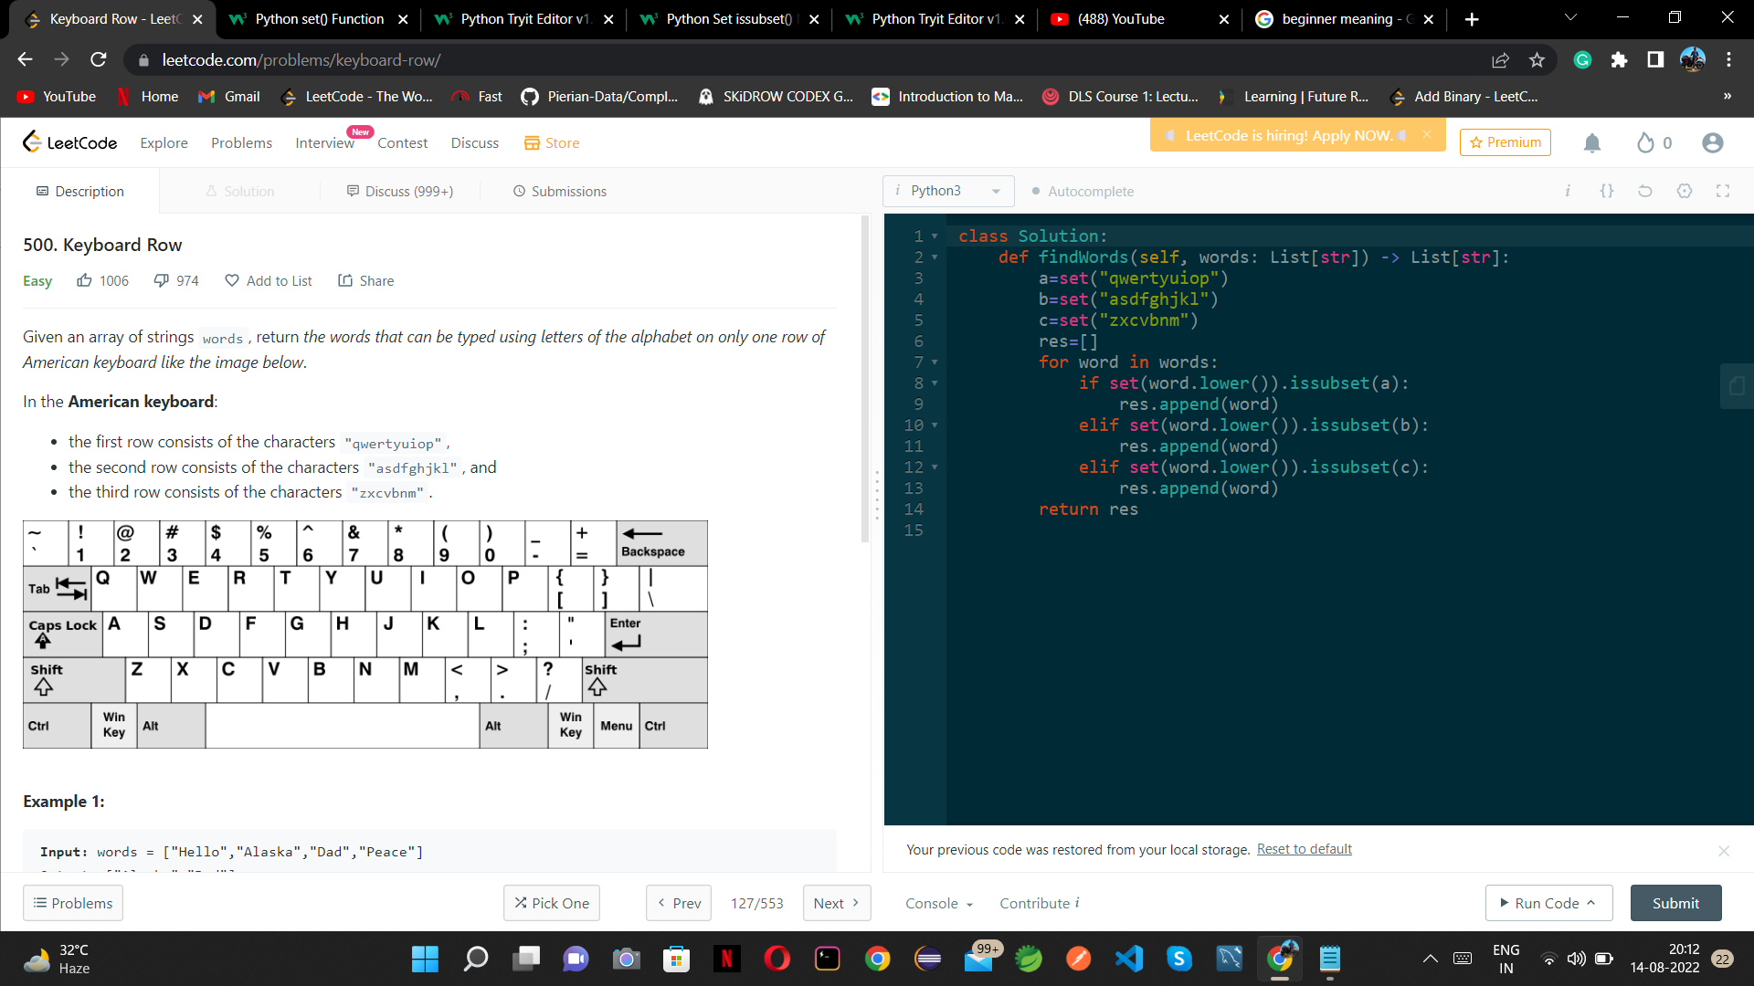

1. Remove()

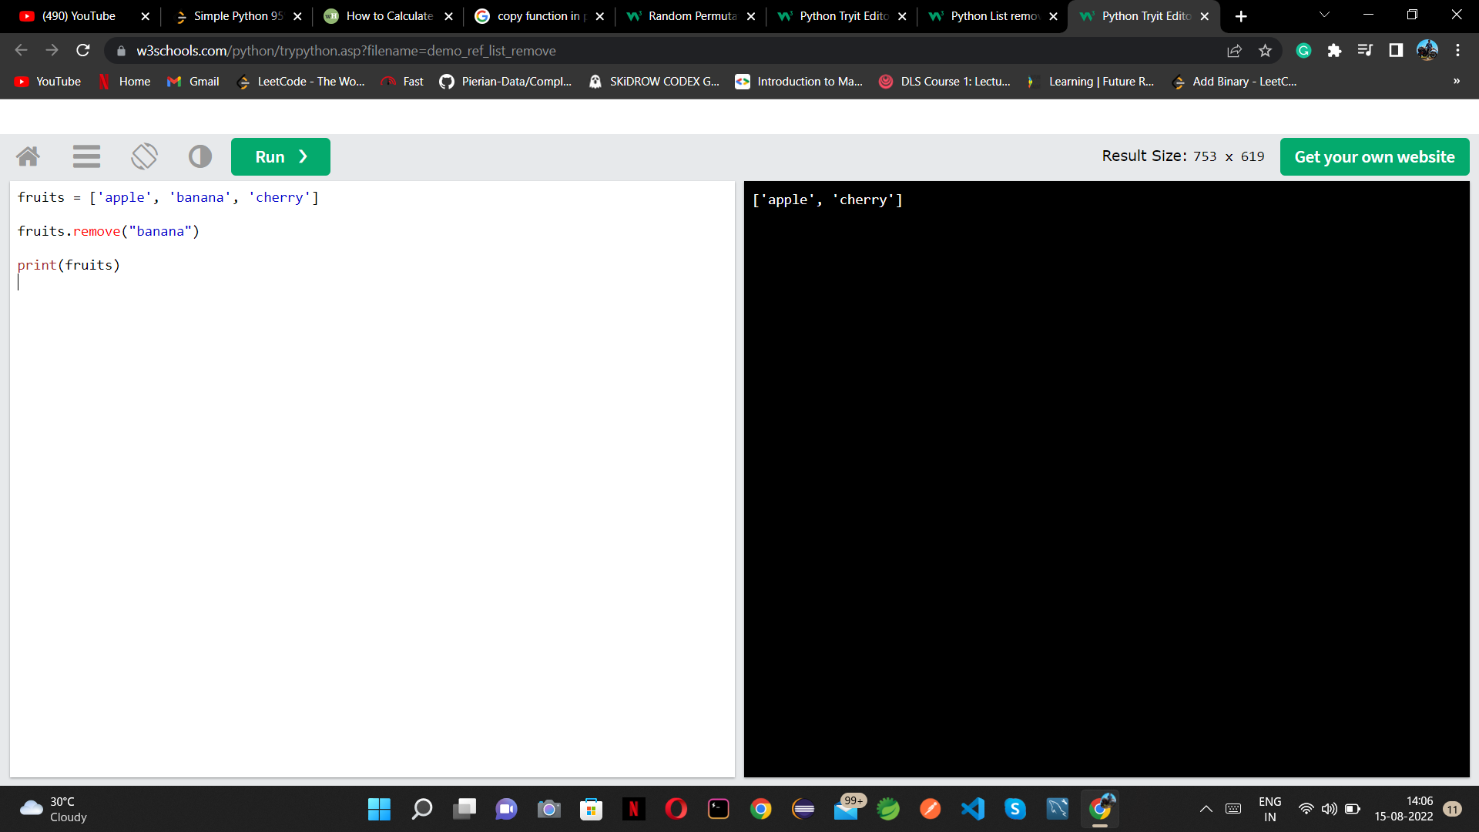

1. Extend()

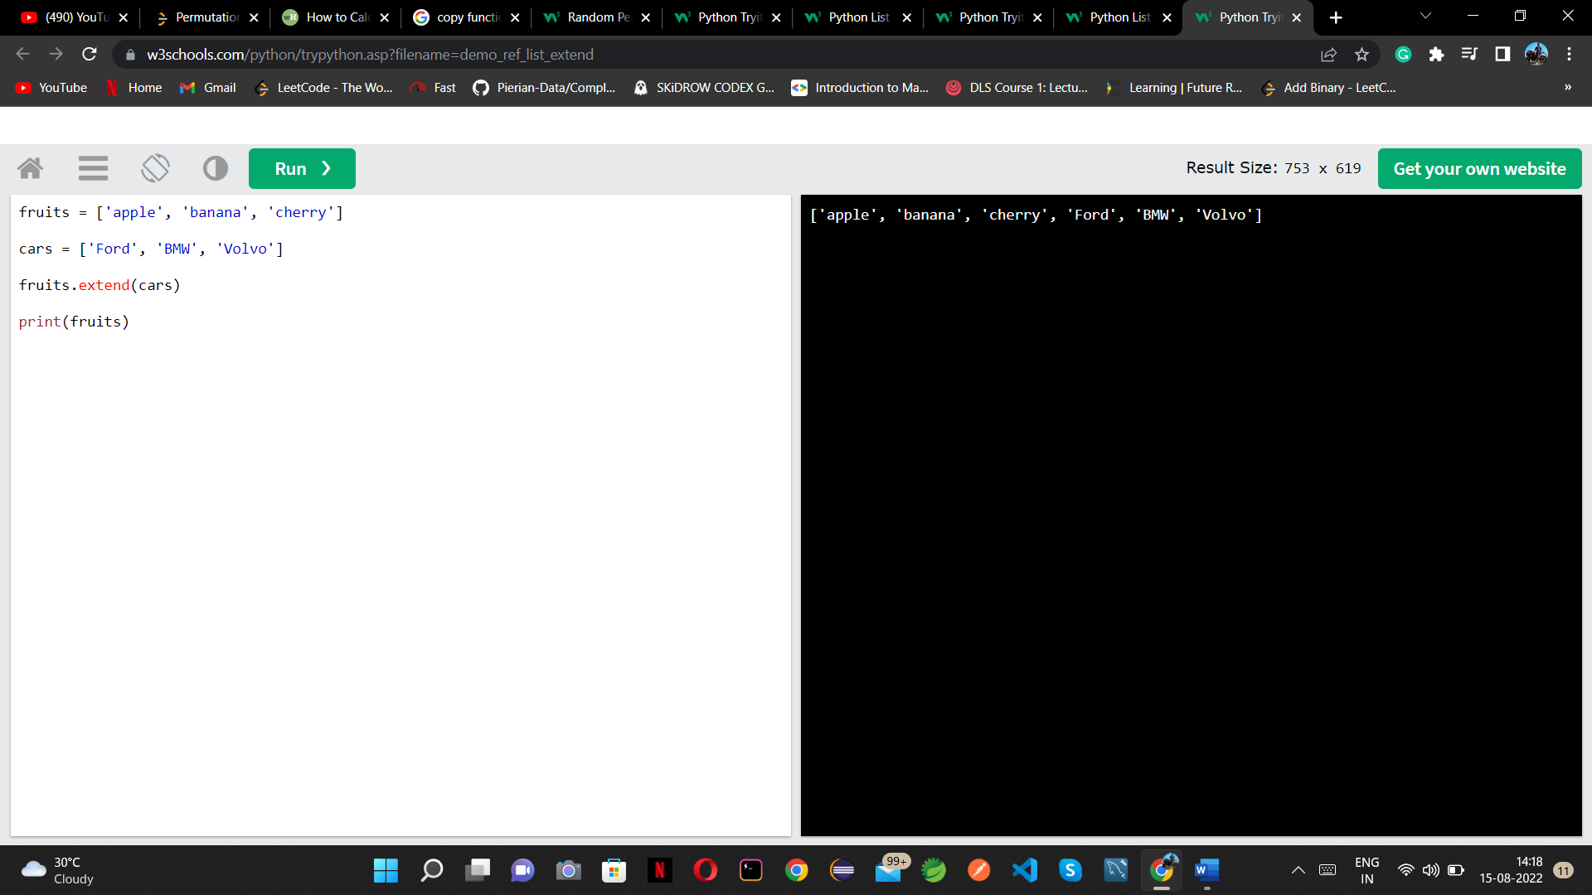

1. Take multiple input from user.

<https://www.geeksforgeeks.org/taking-multiple-inputs-from-user-in-python/\>

1. **Understanding Driver Code**

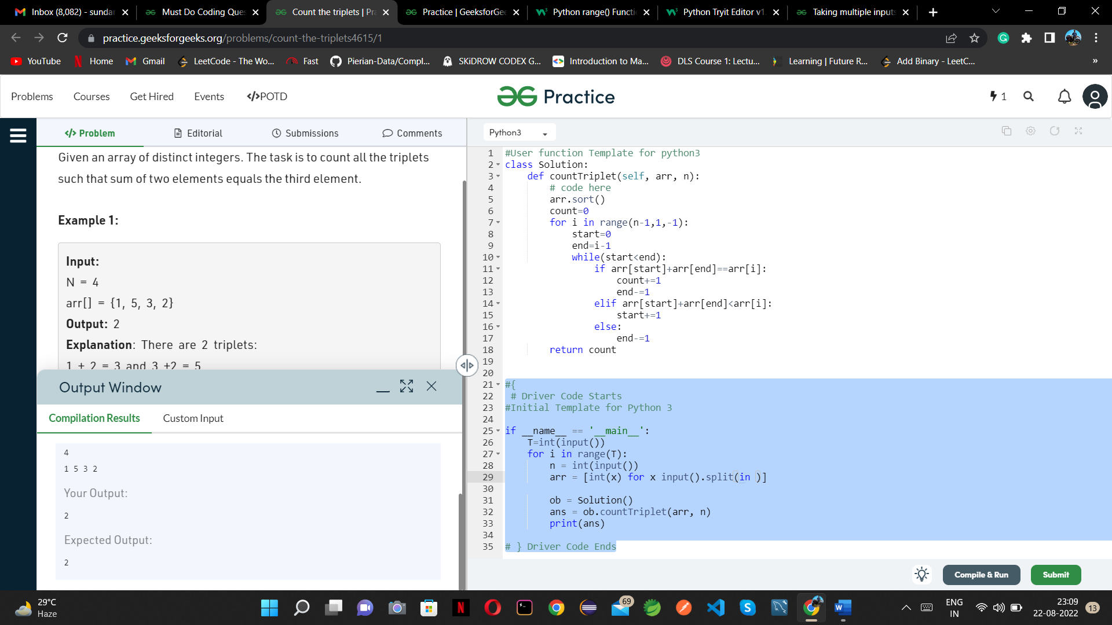

<https://practice.geeksforgeeks.org/problems/count-the-triplets4615/1>

1. // 🡪STORE Quotient

% 🡪 STORE Remainder